**Chapter 7 - QUIZ – Basic Wireless Concepts and Configuration**

1. Match the wireless standard on the left to the appropriate description on the right.

|  |  |  |  |  |
| --- | --- | --- | --- | --- |
| A. | 802.11a | 🡺 |  | Uses the 5.7 Gigahertz band with less interference, but obstructions can affect performance and limit range. |
| B. | 802.11b | 🡺 |  | Specifies data rates of 1, 2, 5.5, and 11 Megabits per second due to differently sized spreading sequences specified in the DSSS modulation technique. |
| C. | 802.11g | 🡺 |  | Uses the 802.11 MAC address, but with higher data rates in the 2.4 Gigahertz ISM band by using the OFDM modulation technique. |
| D. | 802.11n | 🡺 |  | Uses multiple radios and antennae at endpoints, each broadcasting on the same frequency to establish multiple streams. |

1. Match the wireless device to the appropriate description.

|  |  |  |  |  |
| --- | --- | --- | --- | --- |
| A. | Wireless NIC | 🡺 | Encodes a data stream onto an RF signal using the configured modulation technique |  |
| B. | Access point | 🡺 | Connects multiple wireless clients or stations to the wired LAN. |  |
| C. | Wireless router | 🡺 | Connects two separated, isolated wired networks together. |  |

1. At which layer of the OSI model do wireless access points operate?
2. Physical
3. Data link
4. Network
5. Application
6. Which two steps are required for a wireless client to associate with an access point? (Choose two)
7. IP addressing
8. Wireless address translation
9. Wireless client authentication
10. Channel identification
11. Wireless client association
12. Which three WLAN client authentication types require a preprogrammed network key to be set on the client? (Choose three)
13. Open with data encryption disabled
14. Shared with data encryption algorithm WEP
15. WPA with data encryption algorithm TKIP
16. WPA-PSK with data encryption algorithm TKIP
17. WPA2 with data encryption algorithm AES
18. WPA2-PSK with data encryption algorithm AES
19. Which two items contribute to the security of a WLAN? (Choose two)
20. WPA2
21. Use of multiple channels
22. Hiding the SSID
23. Open authentication
24. AES
25. Which term is used for products that are tested to be interoperable in both PSK and 802.1X / Extensible Authentication Protocol (EAP) operation for authentication?
26. Personal mode
27. WPA2 compatible
28. RADIUS authenticated
29. Enterprise mode
30. Pre-shared key authenticated
31. To help ensure a secure wireless network, most enterprise networks should follow which IEEE standard?
32. 802.11a
33. 802.11b
34. 802.11c
35. 802.11i
36. A screenshot of the Linksys GUI shows the wireless security screen and the network authentication entry area with Open as the default. Other options are listed as potential answers. Which method of network authentication provides the highest level of security?

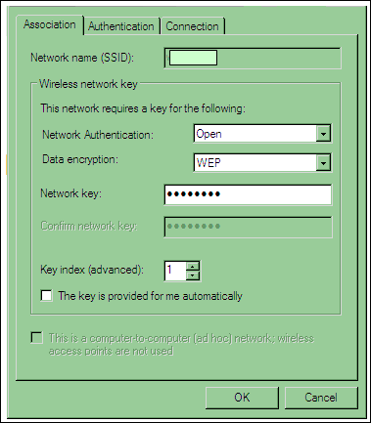

1. Open
2. Shared
3. WPA
4. WPA-PSK
5. Which two combinations of 8 0 2 dot 11b RF channels would allow two wireless AP's to operate simultaneously in the same room with no channel overlap? (Choose two)
6. Channels 10 and 6
7. Channels 9 and 6
8. Channels 8 and 5
9. Channels 7 and 2
10. Channels 6 and 2
11. Channels 6 and 11
12. Why do cordless devices, such as telephones, sometimes interfere with wireless access points?
13. These devices operate at similar frequencies.
14. These devices operate at the same frequencies and have higher RF power settings.
15. These devices flood the entire frequency spectrum with low power noise, which may cause loss of signal for wireless devices trying to connect with an access point.
16. The signal from the cordless device is non-polarized and combines with the access point polarized signal, thus reducing overall signal strength.
17. A laptop computer is positioned at the intersection of two AP range areas that overlap. What is the recommended overlap between the two wireless access points to provide proper connectivity for users?

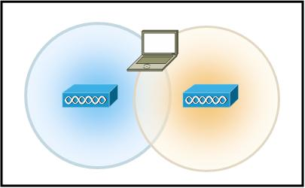

1. 5 to 10%
2. 10 to15%
3. 15 to 20%
4. 20 to 25%
5. Match the authentication method from the left column to the correct encryption algorithm or security protocol it would use on the right.

|  |  |  |  |  |
| --- | --- | --- | --- | --- |
| A. | Open | 🡺 |  | Disabled |
| B. | WEP | 🡺 |  | RC4 |
| C. | WPA | 🡺 |  | TKIP |
| D. | WPA2 | 🡺 |  | AES |

1. Which WLAN client settings would be reviewed to resolve encryption problems with the access point?
2. Wireless mode (802.11a, 802.11b, 802.11g)
3. Wireless network card drivers
4. Channel selection for ad hoc network
5. TCP/IP properties
6. Wireless association properties